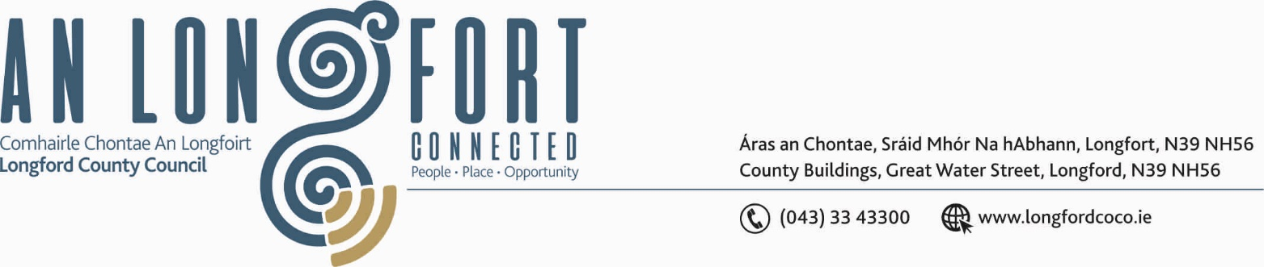

LONGFORD MUNICIPAL DISTRICT

Please note venue and time of meeting.

16th July 2020.

To: Each Member of Longford Municipal District.

Dear Member,

You are requested to attend Meeting of Longford Municipal District to be, held in
Longford Rugby Club, Demesne, Longford on Wednesday, 22nd July 2020 at
2.30 p.m. to transact business, as set out on the Agenda hereunder.


Yours sincerely,

_______________
Anne Lee,
Meetings Administrator.

AGENDA

Prayer before meeting.

- Confirmation of Minutes of the following meetings of Longford Municipal District held on
the 24th June 2020 - copies enclosed

- Committee Meeting.
- 2020 Annual Meeting
- June Meeting.

- Matters arising from Minutes.

- Declaration of Interest by Members.

- Management Report - to follow.

- Abbeycartron Lane and Lisbrack Lane Junctions with Battery Road - Presentation of Junction Options by Longford County Council and Kilgallen & Partners, Consulting Engineers.

- 2020 Community Grant Support Scheme – correspondence enclosed.

- The Attic Youth Café CLG
- Midlands Busking Festival.

- Update on position of Community Warden.

- Dog Fowling in public areas.

- Update on Ballymacormack Cemetery Collabrium Wall.

- Notice of Motion submitted by Councillor Seamus Butler to the March meeting of the County Council -

“That Longford County Council should provide serviced overnight facilities for RUVs
and camper vans. This will mitigate against the blight of such vehicles causing nuisance
by parking in public areas such as Clondra Harbour. It will also attract a category of
tourist that is not currently catered for adequately in the County.”

It was agreed that this Notice of Motion be referred to each of the Municipal Districts.

- Notices of Motions, submitted by Councillors, as listed hereunder –

Councillors Peggy Nolan and Gerry Warnock.

“We are calling on Longford Municipal District to utilise the roundabouts and approach roads into Longford Town as sites for pollinator friendly planting. Not only would this measure be aesthetically pleasing, it would encourage a revival of pollinator insects such as bees who are so vital to a thriving ecosystem. We should liaise with our Environment Section and Longford Tidy Towns Group to draft a pollinator plan for these sites.”

Councillor Gerry Hagan.

“I call on Longford Municipal District to carry out a Low Cost Safety Scheme on the
Cullyfad road at Williamstown. This section of road and is causing a safety hazard for
traffic whereby Minor collisions are regularly occurring at this particular section of road.”

Councillor Seamus Butler.

“That Longford Municipal District calls for a special effort to clean up accumulated
rubbish, general detrius and abandoned vehicles etc from the Ardnacassa Avenue, Palace
and Grian Ard Estates”.

“That Longford Municipal District requests that every effort be made to expedite the
alternative route for the Prison Service Vans to access the Courthouse other than parking
on Main Street”

Councillor John Browne.

“I call on Longford County Council to take in charge the housing development known
as Leader Park”.

Councillor Martin Monaghan.

“That the Council contacts the relevant authority concerning the junction at L5019 and
the N4. This junction at the top of the Knockmartin Road has been the scene of some
serious accidents in recent times. I would urge that this is prioritised.”

“That questions be asked as to why the speed limit on the N4 approaching the railway
bridge on the entrance to Newtownforbes has been increased from 60 Km to 80 Km as
you enter a Sports field and a built up area.”

- A.O.B.



